CROSSROADS DEVELOPER HANDBOOK
Your Guide as a
Crossroads Developer
Build content. Test it live. Partner with AI. Keep the game playable.
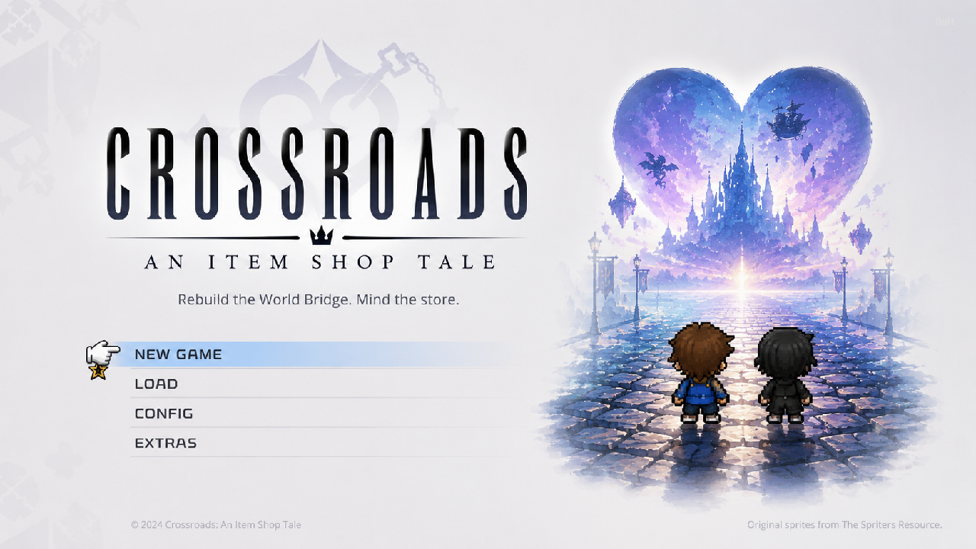
The current Crossroads title screen.
Build reference: bcdb514 | Godot 4.7.1 | July 16, 2026
Repository: github.com/SasukeGabe777/ItemShop

Welcome to the Crossroads development workflow
You do not need to become a Godot scene expert to use the tools in this project. The workflow is intentionally split into a few clear workspaces: play the game normally, inspect and test it with the Live Developer Hub, prepare content with the Asset Factory, design rooms in the Location Workshop, and hand a compact context package to Claude or Codex when you want an AI partner.
THE MOST IMPORTANT RULE Keep the player-facing loop playable. Build one small, complete improvement; test it; record what happened; then commit and push it before moving to the next machine.

Five-minute quick start
- Pull the latest main branch from GitHub and open project.godot in Godot 4.7.1.
- Press F6/F5 or the Play button to run the game. Use New Game for the normal player route.
- While a debug run is active, press F1 to open the Live Developer Hub.
- Use the Hub to jump to the shop, spawn content, change temporary state, record a playtest, or export AI context.
- Return to the editor and open the Crossroads Asset Factory bottom panel to import sprites, create data entries, or use the Location Workshop.
- At the end of the session, update the project notes, run the relevant tests, commit every intended file, and push main.

What is verified right now
- The normal project launches to the title screen.
- The Live Developer Hub opens with F1 in a debug development build and keeps normal saves separate by default.
- The complete small Kingdom Hearts shop-to-dungeon-to-shop loop passes automated coverage, including save/reload.
- The Location Workshop saves briefs, proposals, painted layers, markers, reviews, and launches an isolated test room.
- The Asset Factory is broad and useful, but its chroma-key background auto-detection test still has one known failure.
HONEST STATUS Automated coverage is strong, but several interfaces still need human click-through and visual feedback. A passed test is not the same as a human-approved room or polished player experience.

Contents
Chapter | Topic | Use it for
1 | Choose the right workspace | Normal game vs. Hub vs. Asset Factory vs. AI files
2 | Set up another machine | Clone, pull, install Godot, open, and verify
3 | Play the current vertical slice | Controls and the complete Kingdom Hearts route
4-8 | Use the Live Developer Hub | Every runtime tab and button
9-11 | Use the Asset Factory | Import, items, entities, furniture, browsing, validation
12 | Build locations | Brief, proposal, painting, markers, direct play, review
13 | Work with Claude or Codex | Context export and project working agreement
14-16 | Operate safely | Daily recipes, saves, files, Git, tests
17-18 | Solve problems and choose next work | Troubleshooting and current truth

CHAPTER 1

Choose the right workspace
The tools overlap on purpose, but they are not interchangeable.
Workspace | Where | Best use | Persistence
Normal game | A player session | New Game, shop, customers, negotiation, expedition, save/load | Normal save slots
Live Developer Hub | A debug game is running | Jump, inspect, spawn, edit runtime objects, test state, notes, AI export | Isolated dev state by default
Asset Factory | Godot editor | Import and prepare art, create/update content data, validate | Repository files
Location Workshop | Asset Factory tab | Brief, proposal, paint tile layers, markers, direct room test, review | Repository JSON
AI workspace | Exported by Hub | Give Claude/Codex a compact current-state handoff | Generated, Git-ignored files

THE PRODUCTION LOOP Prepare content in the Asset Factory -> test it in the running game -> record a playtest -> export AI context when useful -> make the smallest revision -> commit and push.

When to use the normal game
Use the normal title screen whenever you need to answer a player question: Can I understand where to go? Can I stock a stand? Does the customer visibly browse and buy? Does the expedition feel readable? Did my save restore what I care about?

When to use the Live Developer Hub
Use the Hub to reach a state quickly or inspect something that would be slow to reproduce normally. It is a development workspace, not the player's experience and not proof that a normal campaign path works.

When to use the Asset Factory
Use the Asset Factory when the change belongs in repository data or processed art: an item icon, hero/enemy/customer sprite set, furniture definition, tileset, authored location, or validation pass.

When to ask the AI partner
Ask Claude or Codex after you can state the player-facing goal and provide current evidence. The AI should inspect first, propose the smallest playable improvement, list intended files, implement, test, and update the status files.
CHAPTER 2

Set up Crossroads on another machine
The repository contains the project; the Godot engine executable is intentionally not committed.

First-time setup
- Install Git and Godot 4.7.1 stable on the other machine. Use the standard or console executable; either can open the editor.
- Clone https://github.com/SasukeGabe777/ItemShop into a normal local folder.
- Open Godot, choose Import, and select the cloned project.godot file.
- Let Godot import assets. The Crossroads Asset Factory plugin is already enabled in project.godot.
- Run the project and confirm the title screen appears.
git clone https://github.com/SasukeGabe777/ItemShop.git
cd ItemShop
git status

ENGINE BINARIES tools/Godot_*.exe is ignored by Git. A local engine copied into tools/ on one machine will not appear on the other machine. Install or copy Godot 4.7.1 separately.

Every time you switch machines
git switch main
git pull origin main
git status

Start only after Git reports a clean working tree or after you have intentionally preserved local changes. If both machines edited the same file before pulling, stop and resolve the conflict deliberately rather than deleting work.

Open the two main interfaces
- Game: press the editor Play button or F6/F5. The configured main scene is the Crossroads title screen.
- Asset Factory: in the editor, click Crossroads Asset Factory in the bottom panel.
- Live Developer Hub: while the game is running in a debug build, press F1.
CHAPTER 3

Play the current Kingdom Hearts vertical slice
This is the smallest complete player loop and the best manual acceptance route.
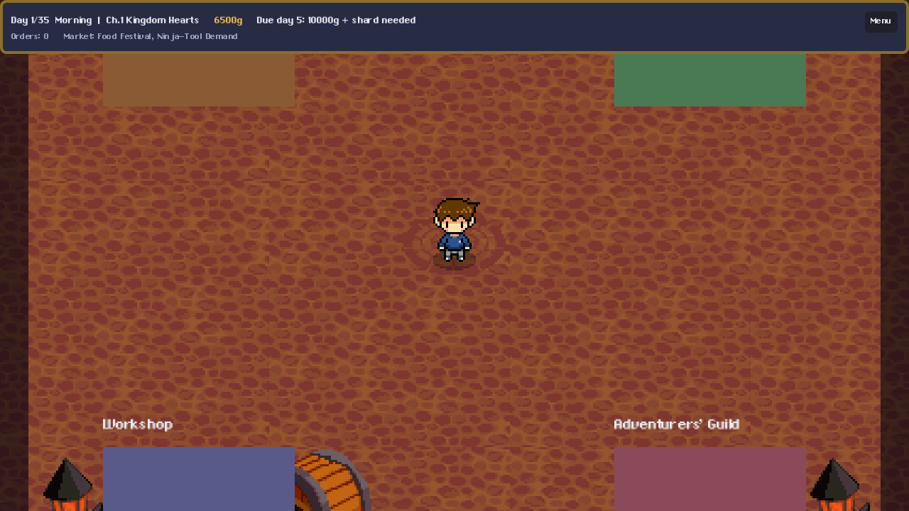
The Crossroads plaza during the current build.

Controls
Control | Action
WASD / arrow keys | Move in town, shop, and dungeon
E | Interact with doors, stands, counters, gates, and prompts
J | Dungeon basic attack
K | Dungeon special
L | Dungeon dodge
I | Use an expedition item
U | Use the finisher when available
F1 | Open or close the development Hub in a debug build

Complete player route
- Launch the game, choose New Game, select a save slot, and continue through the opening dialogue to the Crossroads plaza.
- Enter the Item Shop at the upper-left of the plaza. A new game starts with Potions, Ethers, Gold Coins, and Sora's Kingdom Key.
- Use Rearrange furniture near the lower-right. Select a highlighted stand, move it to a green valid position, click to place it, and press E to finish.
- Walk to that stand, press E at Display slot, and place a Potion, Ether, or Gold Coin.
- Use Open the shop at the top-center counter and confirm the one-period cost.
- Watch the Moogle Broker enter, walk to the live display target, inspect the item, and start negotiation.
- Propose the shown price or accept the counteroffer. Confirm that the item leaves the display and gold increases.
- Finish the session, continue, leave the shop, and enter World Bridge Gates at the north of town.
- Choose Expedition for Traverse Town. Sora is selected for the first run; optionally add a Potion or Ether and depart.
- Walk north through the arrival room. In the combat room, defeat the single Shadow with J attacks.
- Collect the labeled LUCID SHARD. The north exit remains locked until the shard is collected.
- Exit north, confirm the expedition summary, and return to the Crossroads.
- Re-enter the shop, display the Lucid Shard, reopen the shop, and sell it to the returning Moogle Broker.
- Open Menu, Save to slot, Quit to main menu, Load the same slot, and confirm gold, storage, furniture position, display items, and progress remain.
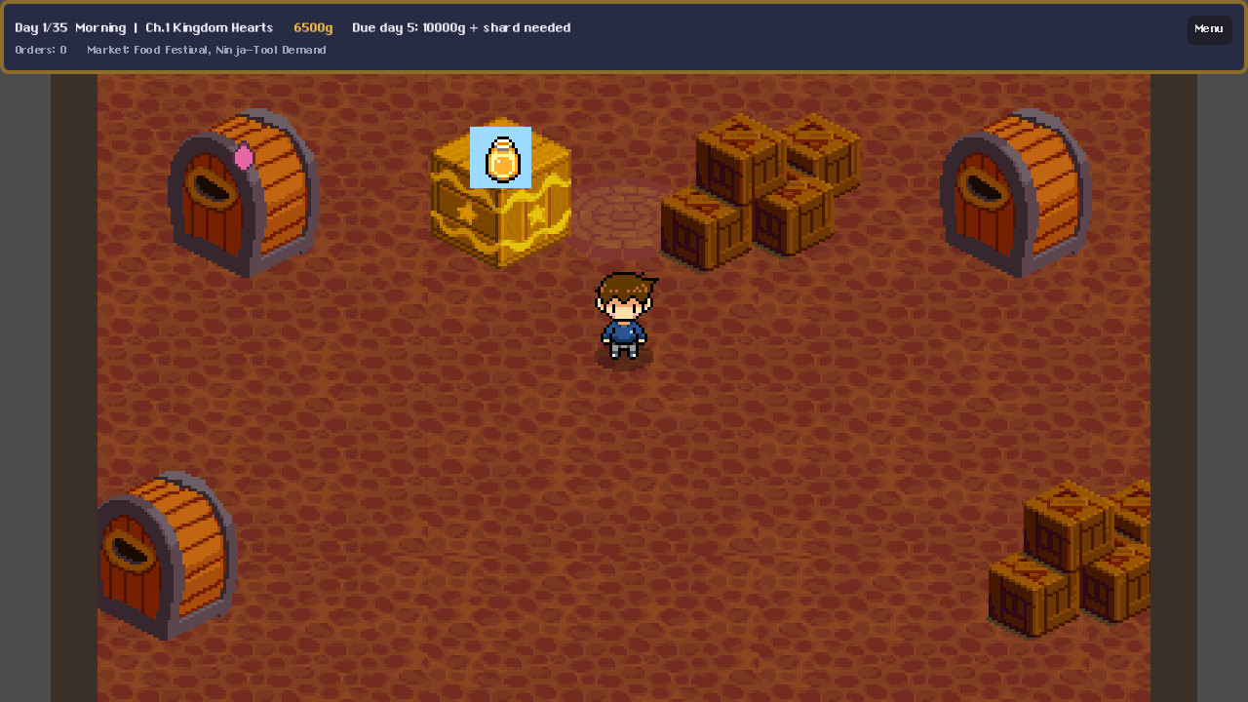
The current shop layout with movable display furniture.
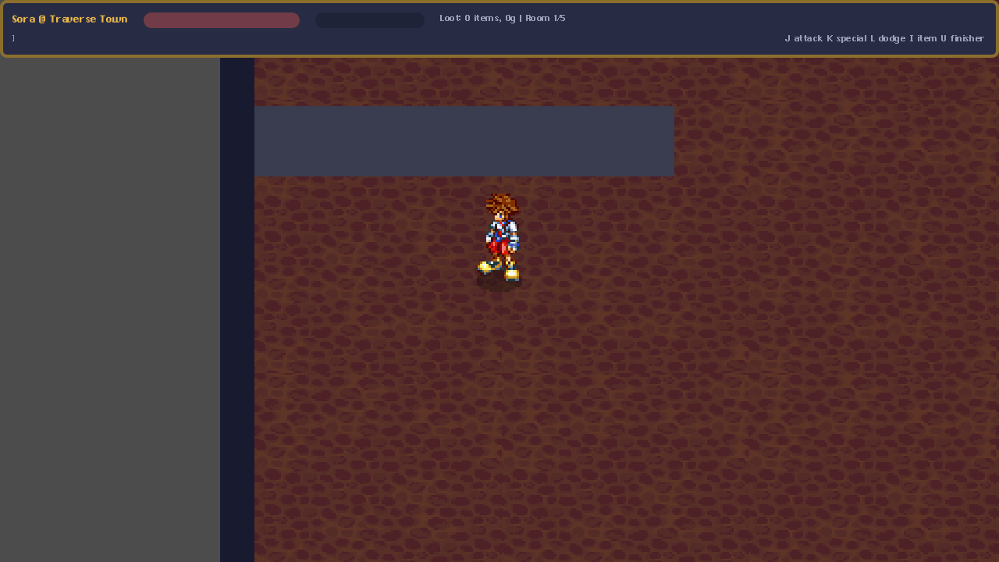
The current Traverse Town dungeon presentation.
RECORD ONLY THE BIGGEST ISSUES During the first human pass, focus on item-placement clarity, customer movement, dungeon-exit clarity, and sale-screen presentation. Fix blockers before adding scope.

CHAPTER 4

Live Developer Hub fundamentals
A development-only overlay inside the actual running game.
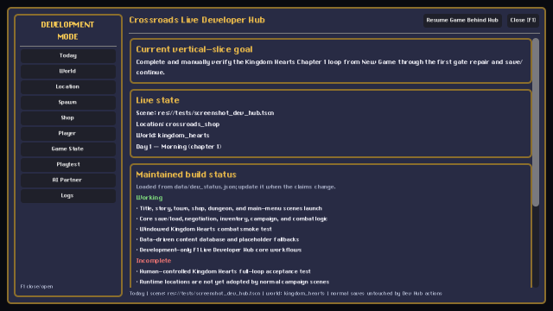
The Today tab and persistent navigation rail.

Open, close, and pause
Control | What it does
F1 | Open or close the Hub. It pauses the game when first opened.
Resume Game Behind Hub | Resume the game simulation while keeping the overlay visible.
Pause Game | Appears after resuming; pauses the simulation again.
Close [F1] | Close the overlay and restore the expected pause state.
Left navigation | Switch among Today, World, Location, Spawn, Shop, Player, Game State, Playtest, AI Partner, and Logs.

Development-mode safety
- The checked-in project enables the Hub only for development/debug use.
- A normal release build stays disabled while development/require_debug_build is true unless explicitly opted in.
- Hub actions start isolated in-memory development state and save to user://crossroads_dev/live_dev_state.json.
- Normal autosaves and chapter checkpoints are suppressed after entering isolated development state in that process.
- Restart the game without entering the Hub when you want a normal player/save session.
DO NOT MIX ACCEPTANCE MODES Use the Hub for development speed. Use New Game/Load without F1 for final player acceptance and normal save verification.

CHAPTER 5

Hub tabs: Today and World
Orient yourself, choose a development world, and jump to the right starting point.

Today tab
Today combines maintained claims from data/dev_status.json with the live scene, selected world/location, day, time, and chapter. It is the fastest place to understand what the current build believes about itself.
Button | Use it when
Play From Title | Close the Hub and route to the normal title screen.
Play From Shop | Create/use isolated development state and load the real Crossroads shop.
Play Kingdom Hearts Dungeon | Jump directly into the Kingdom Hearts dungeon route for combat testing.
Run Kingdom Hearts Full Loop | Prepare the development starting state for the larger KH loop.
Restart Current Scene | Reload the currently running scene.

STATUS CLAIMS Working/incomplete lists are maintained data, not live proof. Update data/dev_status.json when the truth changes, and verify important claims with tests or play.

World tab
Each world row shows hero, item, enemy, customer, location, missing-asset, and incomplete-content counts. A small arrow marks the selected development world.
Button | Effect
Select | Sets the world used by development filters and test-item tools. It does not permanently unlock campaign content.

CHAPTER 6

Hub tabs: Location, Spawn, and Inspector
Build a runtime test layout without manually editing a Godot scene.
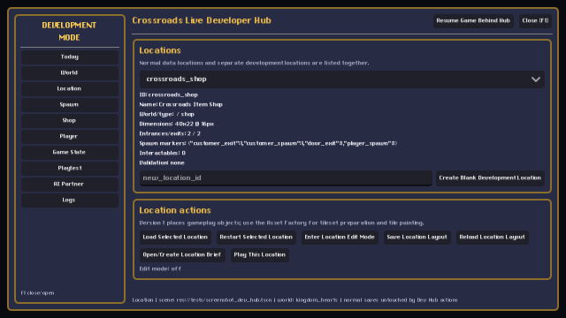
The Location tab with selection, summary, creation, and action buttons.

Location tab
The location list combines built-in gameplay scenes, data-authored locations, and separately saved development locations. Selecting a row shows ID, name, world/type, dimensions, entry/exit counts, marker counts, interactables, and validation problems.
Button | What happens
Create Blank Development Location | Create a new separate runtime layout using the ID typed in new_location_id.
Load Selected Location | Launch the selected built-in, authored, or development location.
Restart Selected Location | Reload the selected location from its starting state.
Enter Location Edit Mode | Toggle runtime object editing for the location.
Save Location Layout | Persist placed development objects in the separate Dev Hub state.
Reload Location Layout | Discard unsaved runtime edits and rebuild from the saved dev layout.
Open/Create Location Brief | Create or locate the brief and copy its path to the clipboard.
Play This Location | Launch the selected location directly.

Spawn tab
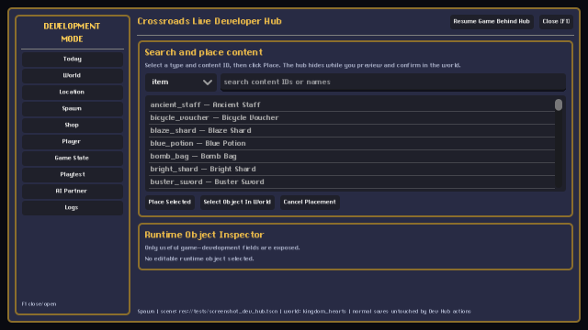
Search content by ID or name, then place or select it in the live world.
Choose item, customer, hero, enemy, furniture, chest, NPC, door, or trigger. Search by ID or display name, select a row, then use one of the actions below.
Button | Effect
Place Selected | Hide the Hub and show the placement preview. Green is valid; red is invalid. Left-click confirms.
Select Object In World | Hide the Hub and let you click an editable runtime object.
Cancel Placement | Cancel the current placement/selection action. Right-click or Escape also cancels.

PLACEMENT BEHAVIOR Appropriate objects snap to the 8-pixel development grid. The preview uses existing runtime scenes/content IDs where possible and safe development representations elsewhere.

Runtime Object Inspector
After selecting an editable object, the Inspector shows its instance ID, content ID, object type, position, rotation, collision, and curated properties. It intentionally avoids dumping every raw Godot property.
Control | Effect
Apply | Apply the X, Y, and rotation fields.
Collision enabled | Toggle collision for the selected object.
Set Target Location / Event ID / Reward Item ID / Dialogue ID | Update the supported game field for a door, trigger, chest, or NPC.
Move | Begin world placement for the selected object.
Delete | Remove the selected development object.
Duplicate | Create a copy using the same content ID and supported properties.
Focus Camera | Move/focus the active camera on the object when supported.
Copy Content ID | Copy the object's content ID to the clipboard.
Open Source / Asset Factory Data | Open or reveal the source content path when possible.

CHAPTER 7

Hub tabs: Shop, Player, and Game State
Exercise real systems while keeping development persistence separate.

Shop tab
The Shop tab only becomes active in the real shop runtime. If you see Shop runtime not active, click Play From Shop. The controls reuse ShopFurnitureManager, DisplayFurniture, InventoryManager, and real ShopCustomer behavior.
Button | Effect
Toggle Shop Edit Mode | Turn live furniture editing on or off.
Clear Displays | Return/clear currently assigned display items.
Fill Inventory With Test Items | Add selected-world goods for development testing.
Open Shop / Close Shop | Start or end the live selling session.
Save Layout (Dev State) | Save furniture/display development state separately.
Reload Layout | Load separate dev state and rebuild real furniture nodes.
Place Furniture | Place the selected furniture definition in the live shop.
Select Furniture To Move | Select a real furniture node in the world.
Remove Selected Furniture | Delete the selected furniture from the development layout.
Assign Item | Assign the selected item ID to the selected display slot.
Summon Selected Customer | Spawn the selected named customer into the real shop session.

CUSTOMER PATHING The reachable display target list shows which live slots customers can browse. Furniture positions and display assignments stay in the existing save-compatible structures; there is no hardcoded crate-only path.

Player tab
Control | Effect
Select Active Hero (Dungeon) | Switch the active expedition hero to the selected existing hero.
Heal | Restore the current supported player.
Revive | Revive a defeated CombatHero when supported.
Reset Player State | Return development-modified player state to its baseline.
Movement speed multiplier | Change movement from 0.25x to 3.0x.
Collision enabled | Toggle player collision.
Teleport To Cursor | Choose a valid world point and move the player there.
Teleport To Player Spawn | Move to a player_spawn marker.
Grant Selected Equipment | Give the chosen weapon/armor/accessory through existing equipment systems.
Clear Hero Equipment | Remove equipment from the selected hero.

Game State tab
Button | Effect
Apply Money Delta | Add or remove the entered amount from current in-memory gold.
Apply Item Delta | Add or remove the entered quantity of the selected item.
Set Day / Period | Set current campaign day and Morning/Afternoon/Evening/Night.
Toggle Temporary World Unlock | Allow development access without permanently unlocking campaign content.
Complete Bridge Repair (Dev) | Mark the selected world's bridge repaired in development state.
Reset Current Chapter | Reset current chapter progress for retesting.
Set Relationship Level | Set the entered customer or hero ID to level 0-10.
Save Dev State | Write user://crossroads_dev/live_dev_state.json.
Load Dev State | Restore the separate dev-state file.

CHAPTER 8

Hub tabs: Playtest, AI Partner, and Logs
Turn live observations into a reproducible next task.

Playtest tab
- Click Start Playtest Session before reproducing the route.
- Play normally or use safe development controls to reach the test state.
- Choose a note category, write expected vs. actual behavior, and click Add Note.
- Click Capture Current State at important checkpoints.
- Click End Playtest Session when the route is complete.
Button | Effect
Start Playtest Session | Start/replace the current report session.
Capture Current State | Write current state and validation snapshots without ending the session.
End Playtest Session | Capture final state and close the session.
Add Note | Save the typed note with its selected category.

Note categories are blocking bug, gameplay issue, visual issue, usability issue, polish, and idea. Reports are written under playtest/latest/: runtime_log.txt, state_snapshot.json, validation_report.json, playtest_notes.md, and screenshot.png when a windowed renderer can capture it.

AI Partner tab
Type the human request for the next session. This should say what player-facing outcome you want, what you just observed, and what must not expand.
Button | Effect
EXPORT CURRENT CONTEXT FOR AI | Write a reviewable package under ai_workspace/current/. No external AI API is called.
Copy Claude Prompt | Copy the standard instruction to read AI_PARTNER.md and the current export, propose the smallest improvement, list files, implement, and test.

The export contains PROJECT_CONTEXT.md, CURRENT_STATE.json, SELECTED_LOCATION.json, AVAILABLE_CONTENT.json, VALIDATION_REPORT.json, PLAYTEST_NOTES.md, and REQUEST.md.
REVIEW BEFORE SHARING The AI export is local and Git-ignored. Read it before sending it outside the repository if future project data may be private.

Logs tab
Button | Effect
Refresh | Rebuild the visible recent log view.
Run Content Validation | Run the Asset Factory content validator and show severity counts/issues.
Clear Visible Log | Clear only the current view; source Godot and runtime logs are not deleted.

Logs combine Hub actions, runtime warnings/errors, missing-asset fallbacks, scene transitions, save/load notices, and validation issues. Use the timestamped lines to anchor a playtest note.
CHAPTER 9

Asset Factory overview
Repository-facing content preparation inside the Godot editor.

Open it
- Open project.godot in Godot 4.7.1.
- Click Crossroads Asset Factory in the editor's bottom panel.
- Choose the relevant tab. Saving a write-side tab reloads the shared content scan and validation state.
Tab | Purpose
Dashboard | Counts, missing assets, broken references, reload, validation, folders
Import Queue | Copy raw incoming art into the selected world's raw folder with provenance
Items | Slice icons and create/update item data
Heroes | Build hero animation manifests and combat data
Customers | Create animated or static named shoppers
Enemies | Create enemies/bosses using reusable AI behaviors
Location Workshop | Brief, proposal, tile painting, markers, direct play, review
Shop Furniture | Create movable furniture/display definitions
Asset Browser | Browse raw/processed assets and provenance
Asset Assignment | Assign raw art to missing processed slots
UI Assets | Inspect/create UI asset folder structure
Validation | Filter and run content errors, warnings, and info

Dashboard buttons
Button | Effect
Reload ContentDatabase | Rescan repository content for the editor dock.
Validate All Content | Run validator and switch to Validation.
Open Data Folder | Open res://data.
Open Assets Folder | Open res://assets.
Open Credits Folder | Open res://credits.

CHAPTER 10

Import art and create content
The shared sprite viewer is the heart of item and entity preparation.

Sprite-sheet preview controls
Control | What it does
- / + | Zoom out or in with nearest-neighbor rendering.
Fit | Fit the full sheet in the preview.
1:1 | Show one source pixel as one screen pixel.
Grid | On: select full grid cells. Off: drag free pixel rectangles.
Clear Selection | Remove selected frames/regions.
Remove BG | Preview/export the chosen background color as transparent.
Color picker / Alt+click | Choose or sample the background-key color.
Tolerance | Adjust per-channel matching tolerance from 0-64.

KNOWN ISSUE The Asset Factory suite currently reports auto-detected wrong background color in one synthetic chroma-key test. Inspect transparent results manually before trusting automatic detection.

Import Queue
- Drop raw sheets into the import queue folder.
- Click Refresh, select a file, and choose the destination world.
- Click Copy to raw/. The original remains in the queue and the destination receives provenance metadata.
- Use Ensure Folder Structure if the selected world's processed directories do not exist yet.

Items tab
- Click Load Sheet... and choose a raw icon/item sheet.
- Select the world, enter Name, Category, and Price, then click one icon tile.
- Click Create Item From Selection. The tool writes the processed icon and upserts data/items.json with review flags.
- To edit, select an item row, change fields, and click Update Selected Item.
- To replace art only, select the item row and a sheet tile, then click Assign Icon to Selected Item. Confirm overwrite when prompted.
Button | Effect
Load Sheet... | Open PNG/WebP/BMP/JPEG source art.
Create Item From Selection | Create a unique item ID, processed icon, sidecar, and data entry.
Assign Icon to Selected Item | Replace only the selected existing item's processed icon.
Update Selected Item | Write name, category, price, and world into the selected data entry.

CHAPTER 11

Create heroes, customers, enemies, furniture, and assignments
Reuse the data-driven systems instead of adding one-off scripts.

Shared entity workflow
- Choose an existing entry or <new>, type the name, select the world, and click Load Sheet....
- Select frames in the sheet. For each animation, use Set = Selection or Append Selection; use Clear or Remove to revise.
- Preview with Play/Stop, previous/next, FPS, and Loop.
- Click Save Hero, Save Customer, or Save Enemy after all required animations are assigned.
- For a background/static character, select one frame and click Save Static Sprite Only.
Animation button | Effect
Set = Selection | Replace the current animation with the selected sheet frames in selection order.
Append Selection | Add the selected frames to the current animation.
Clear | Remove frames from the current animation.
Move Up / Move Down | Reorder a frame.
Remove | Delete a selected frame from the animation.
Play / Stop | Preview the configured animation.

Hero-specific fields
Weapon, HP, ATK, DEF, Move Speed, and Hire Cost. Required animations are idle/walk down, up, and side. New heroes receive playable combat defaults plus needs_ai_balance for later review.

Customer-specific fields
Archetype, Chapter, Budget multiplier, Quirk, and Line. Duplicate Customer copies a selected customer into a new ID, reuses existing art when possible, and marks personality for review.

Enemy-specific fields
Behavior (AI), HP, Damage, Speed, Size, and Boss. Required animations are idle, move, attack, and defeat. Behaviors come from the existing reusable list; checking Boss writes to the boss data array and supplies basic boss defaults.

Shop Furniture tab
Define Name, Type, W/H, display Slots, Attention bonus, Blocks movement, Moveable, and allowed item categories. Furniture feeds the same runtime systems used by the shop and Hub.
Button | Effect
Load Sheet... | Load PNG/WebP furniture source art.
Use Selection as Sprite | Export the selected region to shared furniture art and hold it for the current definition.
Save Furniture | Create/update data/shop_furniture.json with display offsets and runtime settings.

Asset Browser and Assignment
Control | Effect
Raw / Processed | Switch the Asset Browser between source and processed content.
Refresh | Rescan the visible browser/assignment lists.
Copy to Processed... | Copy selected raw art into a processed destination, optionally as an item icon.
Assign from Raw... | Choose a raw file for a missing processed asset slot.
Ensure Folder Structure | Create expected UI/content directories.
Run Validation | Refresh and filter repository validation results.

SOURCE METADATA Keep asset sidecar and credits metadata intact. Raw source art should remain untouched; processed copies are what runtime content consumes.

CHAPTER 12

Build a location with the Location Workshop
A human-readable, AI-readable design loop around the existing tile editor.

Open the Workshop
- Open the Godot editor and the Crossroads Asset Factory bottom panel.
- Choose Location Workshop.
- Follow the numbered tabs from 1 World through 5 Review.

Step 1 - World
Choose the world and optionally an existing location. The availability panel lists saved tilesets, enemies/bosses, items/rewards, NPCs/customers, and authored locations with known exit targets.

Step 2 - Brief
Field | Write this
Location name / Stable ID | Human name and permanent machine ID
Purpose / Location type | What the room does and shop/town/dungeon/story classification
Player experience / Visual theme | What the player should feel/do and how the room should read
Width / Height | Tile dimensions, currently 4-64
Entry / Exit points | Where the player comes from and where each door leads
Enemy / Reward plan | Approved encounter and payoff
Interactables / Story events | Objects and event beats
Design notes | Constraints, reuse, and open questions

Button | Effect
Save Location Brief | Write data/location_briefs/<id>.json.
Load Saved Brief | Load the current ID's saved brief.
Apply Brief to Map | Copy ID, name, world, type, and dimensions into the painter.

Step 3 - Proposal
Click Generate Layout Proposal. This is offline template generation, not an AI call and not an automatic map. It writes <id>.proposal.json with purpose, dimensions, zones, entries/exits, encounter and reward guidance, interactions, risks, missing assets, and acceptance criteria.

Step 4 - Build Map
- Choose an existing tileset and click Use, or click Load Tile Sheet... followed by Save as Tileset.
- Use Fit or 1:1 and the nearest-neighbor zoom controls to inspect source pixels.
- Select a tile in the palette, choose ground, walls, or decoration, and left-drag to paint. Right-drag erases.
- Choose collision and paint blocked cells.
- Choose markers, select a marker type, and click a cell. Drag a marker to move it; right-click to remove it.
- For Exit / Door, enter the target location ID before placing the marker.
- Click Save Location. Select it later from the location list to reload.
Painter button | Effect
Save Location | Write/update the authored location in data/locations.json.
PLAY THIS LOCATION | Save, launch the data-driven room, and initialize safe isolated development state.
Load Tile Sheet... | Open raw PNG/WebP tile art.
Save as Tileset | Copy processed sheet and write grid metadata for the selected world.
Use | Load the selected existing tileset.
- / + | Change map zoom from 1x to 4x with nearest-neighbor pixels.

Marker palette
Marker | Meaning
Player Spawn | Initial player position
Customer Spawn | Shop customer entry point
Customer Exit | Shop customer departure point
Enemy Spawn | Dungeon enemy marker
Chest | Dungeon chest/reward marker
Item Stand | Display/furniture placement marker
Exit / Door | Connection to a target location ID
Dialogue Trigger | Story/dialogue interaction point
Boss Trigger | Boss encounter/event trigger
Shop Counter Area | Preserved legacy shop marker

Step 5 - Play and Step 6 - Review
PLAY THIS LOCATION launches through LocationLoader without selecting a normal save slot. Walk the route and check spawn, navigation, collision, objective clarity, encounter spacing, reward visibility, and the exit.
In 5 Review, set navigation, collision, objective, enemies, and rewards to untested/yes/no; record visual problems, missing assets, and revision notes; then choose approved or revise and click Save Location Review. The result is <id>.review.json beside the brief.
APPROVAL BELONGS TO A HUMAN Automated tests can prove that the workflow saves and launches. Only a human playtest should mark a room approved.

CHAPTER 13

Work with Claude or Codex as a design partner
The AI is expected to inspect, propose, implement, test, and leave an honest handoff.

Start every AI session
- Read AI_PARTNER.md, CURRENT_BUILD.md, NEXT_TASKS.md, and the latest PLAYTEST_NOTES.md entry.
- Inspect the relevant current scenes, scripts, data, tests, and recent Git changes.
- State the player-facing goal in one sentence.
- Propose the smallest playable improvement and warn about unnecessary scope.
- List the files intended for change before editing.

Use the Hub export
- Open F1 -> AI Partner.
- Write the next request in plain language, including what you observed and the success condition.
- Click EXPORT CURRENT CONTEXT FOR AI.
- Click Copy Claude Prompt.
- On the AI machine/session, ask it to read AI_PARTNER.md and everything under ai_workspace/current/.
Read AI_PARTNER.md and everything in ai_workspace/current/. Review the current state, propose the smallest playable improvement, list the files you intend to change, then implement and test it.

Use the location partner prompt
For location work, start from LOCATION_PARTNER_PROMPT.md. The AI must inspect the selected brief, proposal, review, assets, content, and connected rooms; propose before building; identify missing assets; reuse current systems; test with PLAY THIS LOCATION; and update the review honestly.

Finish every AI session
- Test the affected workflow, not only an isolated function.
- Report exactly what passed, failed, and was not tested.
- Update CURRENT_BUILD.md when verified/partial/placeholder truth changes.
- Update NEXT_TASKS.md so the next smallest playable task is first.
- Record useful playtest results in PLAYTEST_NOTES.md.
- Commit and push intended repository files before switching machines.
CHAPTER 14

Common developer recipes
Short paths for the tasks you are most likely to repeat.

Recipe: test an item in the shop
- Run the game, press F1, and click Today -> Play From Shop.
- Press F1, open Shop, and click Fill Inventory With Test Items.
- Choose furniture and Place Furniture if needed.
- Choose a display slot and item, then click Assign Item.
- Choose a named customer and click Summon Selected Customer.
- Click Open Shop and watch the reachable display target and negotiation path.
- Record a Playtest note before changing code if anything breaks or looks wrong.

Recipe: test an enemy quickly
- Use Today -> Play Kingdom Hearts Dungeon or Location -> Play This Location.
- Open Spawn, choose enemy, search the content ID, and click Place Selected.
- Confirm at a green valid point.
- Use Player to heal, revive, change speed, or select a hero if needed.
- Fight with the normal controls so the result still exercises real combat behavior.

Recipe: add an item icon
- Open Asset Factory -> Items and Load Sheet....
- Use Grid/1:1, select the icon tile, then choose world, name, category, and price.
- Click Create Item From Selection.
- Run Validation and inspect needs_ai_balance / needs_description.
- Use the Hub Spawn or Shop tab to test the new content ID in the live game.

Recipe: make and revise a room
- Location Workshop -> 1 World: select world and inspect available content.
- 2 Brief: describe one small goal and save.
- 3 Proposal: generate and review the structured proposal.
- 4 Build Map: paint layers/collision and place markers, then save.
- Click PLAY THIS LOCATION and perform a human navigation test.
- 5 Review: choose revise or approved and save evidence.
- Give the review to the AI partner for only the next justified revision.

Recipe: hand off to another machine
git status --short --untracked-files=all
git add .
git commit -m "Describe the completed playable change"
git push origin main
git status
git rev-parse HEAD
git ls-remote origin refs/heads/main

CHAPTER 15

Save safety and important files
Know what is repository content, generated evidence, normal player state, or separate development state.
Kind | Path | Purpose
Normal saves | user:// save locations managed by SaveManager | Player campaign slots, autosave, checkpoint
Dev Hub state | user://crossroads_dev/live_dev_state.json | Separate money/inventory/layout/testing state
Authored locations | data/locations.json | Repository map layers, collision, markers
Location design | data/location_briefs/<id>.*.json | Brief, proposal, review
Playtest output | playtest/latest/ | Generated logs/snapshots/notes; contents ignored by Git
AI export | ai_workspace/current/ | Generated handoff package; contents ignored by Git
Build truth | CURRENT_BUILD.md | Verified, partial, and placeholder systems
Priority | NEXT_TASKS.md | Next playable work in order
Development record | PLAYTEST_NOTES.md | Reusable human/automated results
AI rules | AI_PARTNER.md / LOCATION_PARTNER_PROMPT.md | Session behavior and location partnership

What Git does not carry
- The .godot import cache and *.import artifacts.
- Local Godot engine executables under tools/Godot_*.exe.
- Normal user save files and separate user:// development state.
- Generated contents of playtest/latest/ and ai_workspace/current/.
- Local music overrides and downloader output.
SWITCHING MACHINES Commit repository data and documentation, then push. Do not expect user:// saves, ignored AI exports, playtest outputs, or the engine executable to arrive through GitHub.

CHAPTER 16

Validate, test, commit, and push
A clean handoff requires evidence and exact remote verification.

Set a reusable Godot path in PowerShell
$Godot = "C:\Path\To\Godot_v4.7.1-stable_win64_console.exe"

Core validation commands
& $Godot --headless --path . tests/test_boot.tscn
& $Godot --headless --path . tests/test_parse_all.tscn
& $Godot --headless --path . tests/test_dev_hub.tscn
& $Godot --headless --path . tests/test_location_workshop.tscn
& $Godot --headless --path . tests/test_kh_vertical_slice.tscn

Success line | What it proves
BOOT_TEST_PASS | Content data loads and core references resolve.
PARSE_TEST_PASS | Current scripts compile and listed scenes instantiate.
DEV_HUB_TEST_PASS | Hub isolation, placement, shop integration, reports, AI export, and save safety.
LOCATION_WORKSHOP_PASS | Brief/proposal/map/markers/review/direct play workflow.
KH_VERTICAL_SLICE_PASS | Starter inventory, stand, customer sale, Sora dungeon, loot resale, save/load.

READ THE OUTPUT A process exit code is not enough. Search for *_FAIL and confirm the expected *_PASS line. The Asset Factory chroma-key test is a known current failure.

End-of-session Git checklist
- Run git status --short --untracked-files=all and inspect every line.
- Run git diff --check and review the actual diff.
- Stage intended files with git add . only after confirming there are no accidental secrets or generated junk.
- Commit with a message describing the completed outcome.
- Fetch/pull if needed, then push origin main.
- Verify local HEAD and refs/heads/main on GitHub are the same hash.
- Confirm git status is empty before leaving the machine.
CHAPTER 17

Troubleshooting
Start with the symptom, protect existing work, and use the narrowest fix.
Symptom | Likely cause | What to do
F1 does nothing | Game is not a debug/development run, focus is elsewhere, or settings changed | Run from Godot editor; confirm development/enabled=true and require_debug_build=true.
Shop tab says runtime not active | You are not in the real shop scene | Today -> Play From Shop, then reopen F1 -> Shop.
Player tab has no supported player | Current scene lacks TownPlayer/CombatHero | Load town, shop, or dungeon first.
Placement is red | Collision, bounds, or furniture validation rejects the point | Move to open space until VALID appears; then left-click.
Placed object vanished | Layout was not saved or dev state was reloaded | Use Save Location Layout or Save Layout (Dev State) before leaving.
Location not in Workshop | data/locations.json has not been saved/rescanned | Save Location, reload the Asset Factory, and run validation.
No tileset listed | The selected world has no saved tileset metadata | Load Tile Sheet..., configure grid, and Save as Tileset.
Tiles look blurry | Non-integer view or source filtering | Use 1:1 and integer map zoom; the Workshop forces nearest-neighbor.
Normal save seems changed | Normal and development sessions were mixed | Restart the game without entering F1 and verify through normal Load.
Placeholder art appears | Processed asset is missing | Use Dashboard/Validation to find the missing slot; assign or import art.
Remove BG looks wrong | Known auto-detection weakness or tolerance mismatch | Alt+click the actual background color, lower tolerance, inspect export manually.
AI cannot see exported context on other machine | ai_workspace/current contents are Git-ignored | Export again on that machine or transfer the package deliberately.
Git says clean but local engine is missing | Engine binaries are ignored by design | Install/copy Godot 4.7.1 separately.

When to stop and ask
Stop before deleting, resetting, or overwriting work you do not understand. Ask for help when a merge conflict touches the same feature on both machines, a save migration affects real player data, or a proposed change expands beyond the requested playable task.
CHAPTER 18

Current truth and recommended next steps
Use the tools to gather evidence, not to hide unfinished player experience.

Strong, verified foundations
- Title-screen launch and core content loading/parsing.
- Normal save/load core and the automated small Kingdom Hearts vertical slice.
- Live Developer Hub isolation, spawning, object inspection, shop integration, state changes, playtest output, and AI export.
- Location Workshop brief/proposal/painting/markers/review/direct-play workflow in automated scratch coverage.

Still partial or awaiting human acceptance
- A full human playthrough of the small KH route without development tools.
- Native editor usability of the Workshop during a real authored room, followed by a human approved/revise review.
- Campaign routing for data-authored locations; normal town/shop/dungeon scenes still author layouts separately.
- Asset Factory chroma-key auto-detection and end-to-end manual imports across every tab.
- Visual polish, especially shop HUD, sparse dungeon rooms, and placeholder art.

The next smallest valuable work
- Personally play the complete Kingdom Hearts route in Chapter 3 without F1 or editor help.
- Record only the largest blocker in item placement, customer movement, dungeon exit clarity, or sale presentation.
- Fix that blocker and replay from the nearest normal save.
- Separately, author one tiny real room through the Location Workshop, click PLAY THIS LOCATION, and save a human approved/revise review.
- Only connect the new room to campaign routing after it proves as playable as the current preset.
DEVELOPER MINDSET The tools are successful when they help you produce a clearer player experience. Prefer one complete, tested loop over seven broad unfinished worlds.

Your daily closing line
Before you leave a machine: tests read correctly, status notes tell the truth, git status is clean, the commit is pushed, and local HEAD matches GitHub main.

